Hi HR Team,

To run this coding session, please follow these steps:

1. Run corp deck presentation within first 5 minutes
2. Ask the candidate to explain their project experiences
3. Share the codesandbox link below to the candidate:
   1. React JS: <https://codesandbox.io/s/movie-catalogue-react-js-challenge-jp75rs>
   2. Angular: <https://codesandbox.io/s/movie-catalogue-angular-store-challenge-pyf70q>
   3. Vue JS: <https://codesandbox.io/s/movie-catalogue-vuejs-challenge-hkbdc>
4. Ask the candidate to FORK the codesandbox mentioned in step #1.

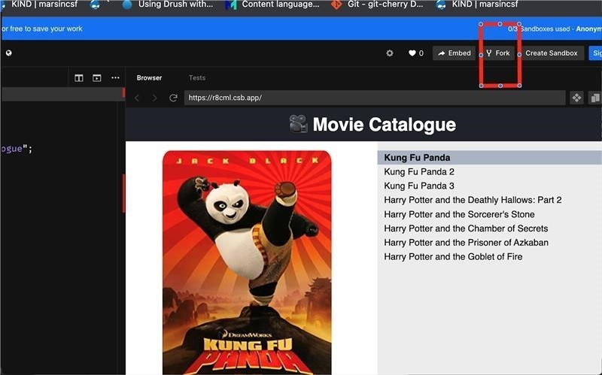

1. Ask the candidate to share the link of their forked codesandbox mentioned in step #2 to you.
2. Tell the candidates that they need to fulfill below requirements:
   1. When the user selects a movie, the selected movie should be greyed out.

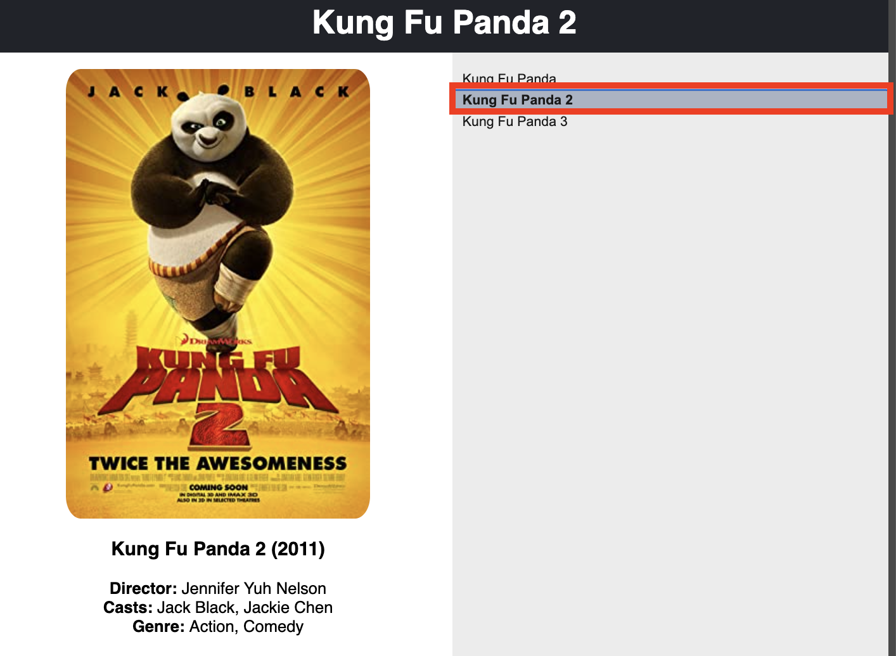

* 1. When the selected movie is changed, the movie preview on the left side should be changed with corresponding movie data.

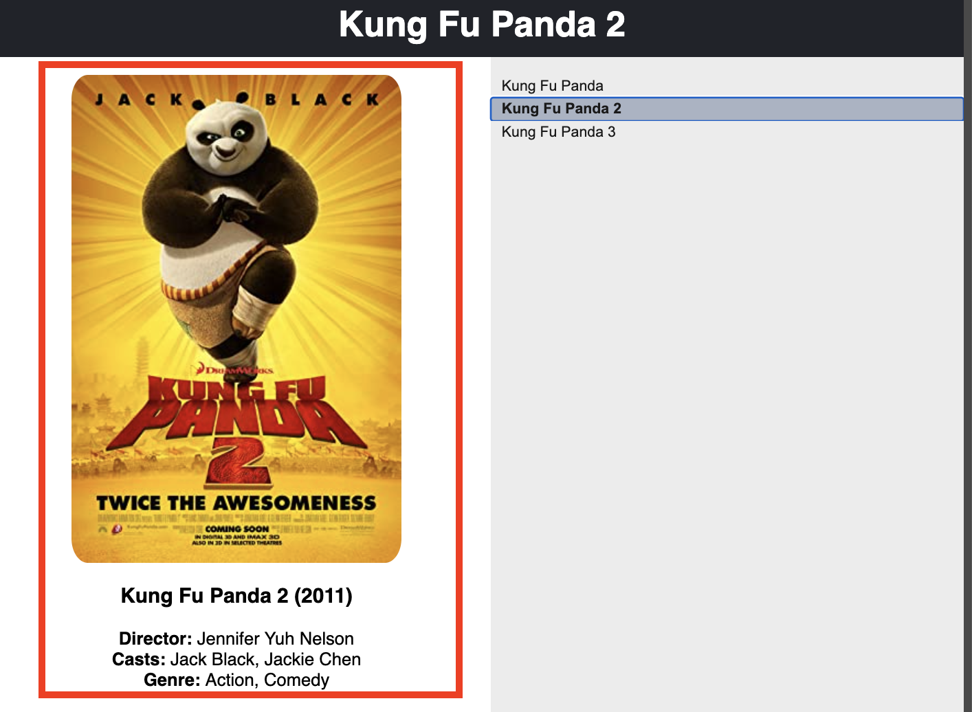

* 1. When the selected movie is changed, the header title should be changed with corresponding movie title. 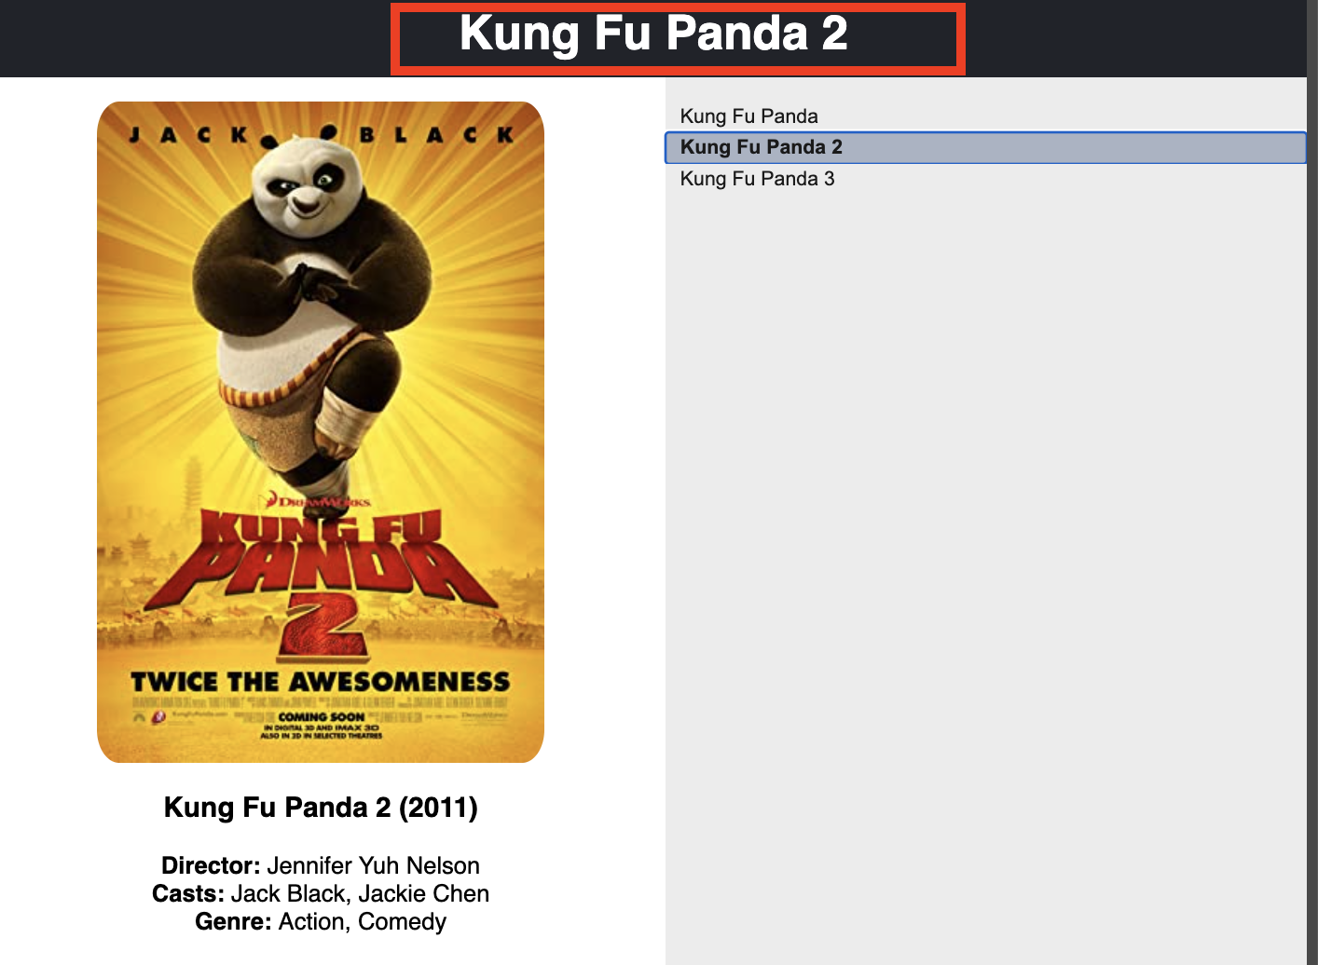

1. The candidate should code their solution on that forked codesandbox mentioned in step #2. Ask them to save their code changes (Cmd+S) in MAC OS or (Ctrl+S) in WINDOWS OS.
2. The candidate should finish the coding test with max 45 minutes duration.
3. Ask them to explain the solution they gave.
4. HR team to share [Coding Test Review](https://phtn-my.sharepoint.com/:x:/g/personal/momo_photon_in/EZCKlMq6gchBqVeYlDUlXB4BgVkMx4mwo9z3NJRBJzQkFQ?e=noP6tL) sheet to the panelist to update.
5. HR team to add below details in [Coding Test Review:](https://phtn-my.sharepoint.com/:x:/g/personal/momo_photon_in/EZCKlMq6gchBqVeYlDUlXB4BgVkMx4mwo9z3NJRBJzQkFQ?e=noP6tL)
   1. Codesandbox link mentioned in step #2
   2. Recording file
   3. JIRA link for the panelist to review.
6. Any doubts/queries please feel free to reach out to me through MS Teams chat at [ratih.nurmalasari@photon.com](mailto:ratih.nurmalasari@photon.com)

Thanks,

Ratih.